Marlborough
Primary
School
Information for Starting Nursery
2020

Useful contact information:
Marlborough Primary School
Blenheim Road
Cardiff
CF23 5BU
Tel: 02920 492 564
E-mail: marlboroughprm@cardiff.gov.uk

Headteacher: Miss Geraldine Foley
Assistant Headteachers: Mrs Leah Crew, Mrs Sally Hodges and Mrs Rachel Lloyd

Nursery Staff:

Mrs Rachel Lloyd Nursery Class Teacher
Monday, Tuesday and Friday morning

Mrs Caroline Norton Nursery Class Teacher
Wednesday, Thursday and Friday

Mrs Shahida Begum Nursery Teaching Assistant – full time

Miss Anna Parr Nursery Teaching Assistant – full time

Session Times

The youngest children are organised into the morning Melyn class, whilst the oldest children in the afternoon Coch class.

Melyn Class 9.00 a.m. – 11.30 a.m.
Coch Class 12.50 p.m. – 3.20 p.m.

Dropping Off and Collecting Children

The Nursery entrance is situated next to the main entrance on Blenheim Road. The doors will open a few minutes before the start of the session to give children plenty of time to hang up their coats in the cloakroom area.

Please line up with your child, remembering to social distance from other parents and carers.

We will ask you to provide a list of family members and friends who will make the regular drop offs and pick-ups. Should an arrangement change at short notice please telephone the school office and leave a message. If an unfamiliar adult should collect your child we will telephone home to confirm that a new arrangement has been made.

If you arrive late or need to pick your child up early, please ring the bell at Reception and Mrs James will inform Nursery staff to meet you at the Nursery door.

Illness

If your child is unwell and unable to attend Nursery please email or telephone the office so that their absence can be recorded.

Due to the current Covid 19 situation if you have any concerns about your child please speak to a member of staff. If we suspect your child has any Covid symptoms we will call you to collect your child – see below.

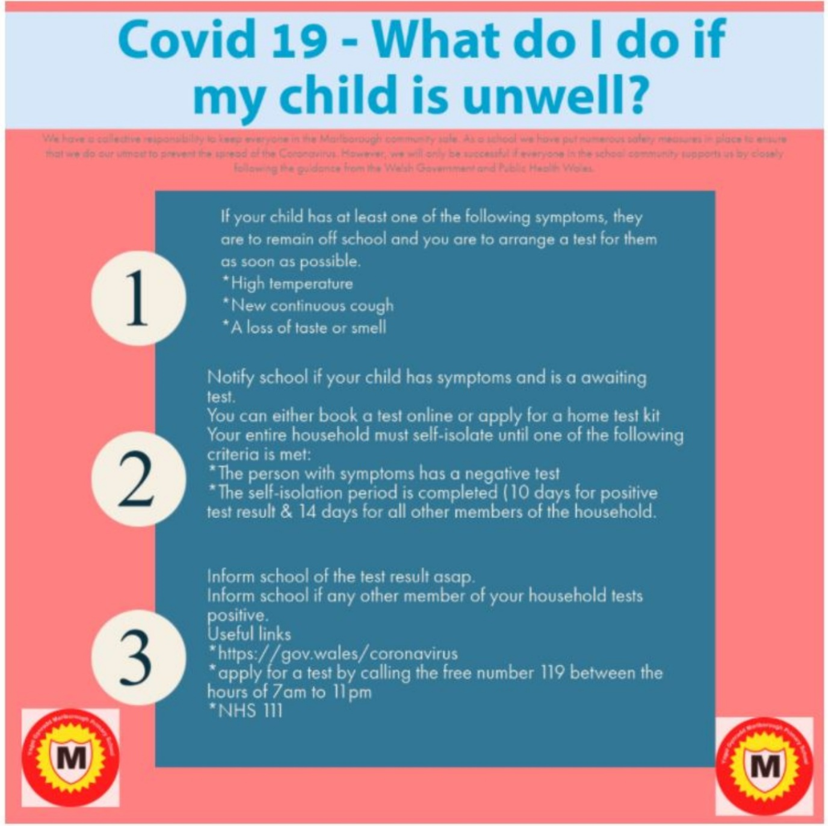

If your child has a sickness bug they will not be able to attend Nursery for 48 hours after the final bout of sickness or diarrhoea.

Please keep us informed of any changes to mobile numbers or email addresses.

What will your child need to bring?

A Raincoat – unless the weather is very cold or wet we do endeavour to spend some time outdoors every day. Please send your child with a shower proof coat, preferably with a hood.

A Water Bottle – send a bottle of water (no juice) labelled clearly with your child’s name.

Healthy Snack – send a small snack box containing one or two items of chopped fruit or vegetables such as carrot sticks, apple, orange. A small banana or crackers would also be accepted. Please DO NOT send grapes (choking hazard) or any nut products (we do have a number of staff and children who have severe allergies to nuts in school).

Change of Clothes – only if your child is not toilet trained or has frequent accidents.

What will my child wear?

School uniform is optional in Nursery but is chosen to wear by most children in Marlborough.

Children usually wear:
- Grey skirt, slip, trousers or joggers
- Red or white polo shirt
- Red jumper or cardigan with the school logo which can be purchased from the uniform shop YC Sport’s on Crwys Road
- Practical shoes or trainers

Please note that due to Covid 19 we suggest that clothes worn in the setting are washed after attendance.

Medical Information

Please speak to a member of the Nursery Team if your child has any allergies or medical needs. If your child will need medication for allergies, asthma or other medical conditions, we can store medication in the setting but we will required to complete a medical consent form for staff to administer any medication stored.

If your child has been receiving support from other agencies such as Speech and Language please let us know, we can support you with any strategies you may use at home and follow any advice given.

Toileting
There may be an occasion where your child may have a toilet accident in Nursery; this is always to be expected at some time during the year and all children will be changed quietly and discretely.

This year, due to the Covid 19 situation, if your child has diarrhoea, a phone call home will be made to collect your child.

If you need support with toilet training, we are always happy to work with you to make this a success.

If your child is dry at home please do not send them in nappies or pull ups; we will encourage your child to use the toilet independently in class.

How will we keep your child safe during the Covid 19 pandemic?

- All children will wash their hands as they enter the setting, before eating and as they go out to play.
- Children will remain within the Nursery ‘heart’ zone.
- The Nursery staff will social distance from the children; visors will be worn if we work within close proximity to a child.
- Toys and equipment will be either rotated or cleaned after each session, to avoid cross-contamination between classes.
- We will use this story with the children:
https://www.youtube.com/watch?v=2PnnFrPaRgY&feature=youtu.be&app=desktop
- We will be vigilant about symptoms and will call you to collect your child should we have any concerns.

How can you help your child to become independent?

There are a number of practical ways you can help prepare your child for Nursery at home:

- Encourage them to put on and take off their own coat.
- Show them how to use a tissue to wipe their nose.
- Show them how to wash and dry their hands at the sink.
- Encourage them to use the toilet independently (including wiping and flushing).

What will they learn?

Please sign up to Seesaw our online learning platform. We will use this regularly to communicate messages and share your child’s learning experiences with you at home.

The children will be in groups of 5 or 6; this year the group names are ladybirds, butterflies, grasshoppers, dragonflies, caterpillars and bumble bees.

During each session each group will complete two fun learning experiences or activities with an adult, spend time playing outside as well as accessing independent play in class.

We will have time for daily songs and stories.
Greater detail about how we teach literacy, numeracy and other areas of the curriculum will be shared in the coming weeks.

Our first topic will be ‘Getting to know you’

How can you help your child settle into the new routine?

- Please encourage good sleeping habits, share stories before bed.
- Make mealtimes a regular family affair.
- Show your child how to share and take turns.
- Talk to your child and role model clear speech
- Encourage your child to help tidy up.
- Be positive about new experiences.

Talk to your child about starting Nursery; reassure them that it will be new but lots of fun and very exciting.

Further Questions

When you bring your child for their first session, the staff will ask you to stay or return for a short 15 minute meeting, to discuss the pupil questionnaires. The meeting time will be decided with you as you drop off. If you are not able to meet with the teacher an alternative time can be arranged or a phone call made.

This meeting should give you time to ask any further questions you may have.

Please note that unfortunately this year we will not be able to allow parents to join the children in the class for the first settling in session.

With many thanks,

The Nursery Team

