SEPTEMBER 2020

MARLBOROUGH PTA NEWS
Welcome back to the new school year – it’s so nice to see familiar faces in the playground, albeit in a socially-distanced way.
As you can imagine, we had grand plans for raising money for the school this year but most of these have been put on hold whilst we work through the pandemic, ensuring we limit the threat of coronavirus affecting the school and our children.
We’re still hopeful that these may come to life next year, but in the meantime, we’re looking for virtual fundraising ideas. If you have any ideas, please do get in contact. A ROUND UP OF MONEY RAISED
Last year we had a fantastic response to our events and fundraising initiatives and raised a whopping £9,279.19. This money would not have been possible if it wasn’t for your continued support, so thank you.
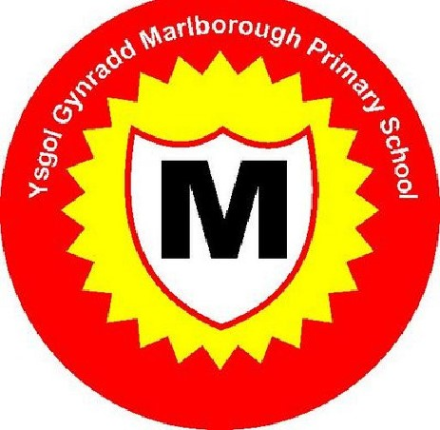
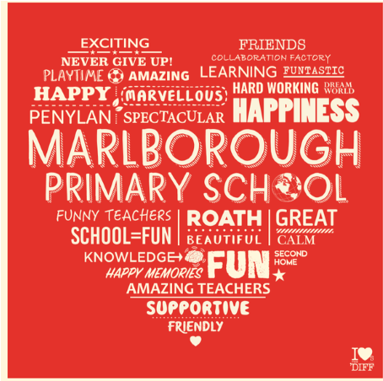
So far, this term we’ve provided £800 for pan-school resources, whilst £200 has been given to the school to allow them to buy Covid-19 measures including hand sanitiser, cleaning products and individual wallets for the children’s belongings.
SNUG GOES WILD!
This term, PTA funds have also answered a call from Mrs Dent as she looks to establish an additional outdoor SNUG area.
The SNUG area at Marlborough is well-received by pupils across the school, providing them with a wellbeing space. It is available to any child who is experiencing challenges with emotional regulation, the beginnings of mental health difficulties and short or long-term trauma. The SNUG is used to support individuals and small groups to provide them with a sense of value and belonging within our school community.
Mrs Dent contacted the PTA for support in getting the outside SNUG up and running. Only too happy to help, we’ve provided £500 to buy some raised planters and tepees, which will both enhance the outside area and allow pupils to build new skills, whilst benefiting from a connection to outdoors.
As the area gets established, Mrs Dent is also keen to hear from parents who may be able to donate plants, cuttings or seeds for this new venture. If you are able to provide any of these, please drop them off in the outside area next to the main reception.

100 CLUB LAUNCHES TO BENEFIT ‘PLAYERS’ & SCHOOL
With face-to-face fundraising limited at present, we’ve launched the new Marlborough 100 Club.
It’s is a great, hassle-free way to support the PTA by raising much-needed funds for school whilst also being in with a chance to win a cash prize – each month!
So, what is it?
A 100 Club is a form of private lottery. Subscribers buy numbered tickets which are entered into a regular draw - 100 tickets for a 100 Club. The number can vary to suit the size of our school, e.g. 200 tickets for a 200 Club, and so on.
How does it work?
Participants pay £5 for each number they purchase and when the tickets are drawn, a percentage of the profit is given as a cash prize, with the remainder going to PTA funds. We will publish the month’s winners on our Twitter and Facebook pages on the last Wednesday of every month and will transfer winnings electronically by Friday.
What happens?
Each £5 donated per month buys you your own number and gives you a chance to win one of three monthly cash prizes from 20% of the monthly subscriptions. You can buy as many numbers as you like, by filling in the mandate that was emailed earlier in the term. If you’re missing the information please email the PTA.
ONLINE SHOPPING? YOU CAN HELP....
If you’re shopping through Amazon you can support the PTA, with no cost to you! We’ve signed up to Amazon Smile, so if you shop at Amazon please consider using the link below and saving it in your favourites.
Every time you shop via the link, Amazon donate funds to our charity – at no extra cost to you.
Please follow this link: https://smile.amazon.co.uk/ch/1093375-0.

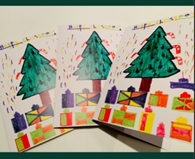
CHRISTMAS CARDS MAKE A COMEBACK
Following the success of last year’s Christmas cards made by our children, we’ve decided to run this again.
Children are currently in the process of channelling their inner-Picasso, coming up with fantastic designs, and information on how to purchase cards, gift tags and mugs will be sent to parents in due course.
This year orders will be placed online by parents directly through a dedicated website, saving the handling of cash.

A ‘BAGFUL’ OF SUPPORT FOR MARLBOROUGH
If you’re looking for water bottles and tote bags, we still have our Marlborough I Loves the ‘Diff’-designed products for sale.
These are priced at £5 each and can be requested through marlboroughprimaryc@gmail.com.
Drop us a line and we can organise a socially distant way to get them to you.
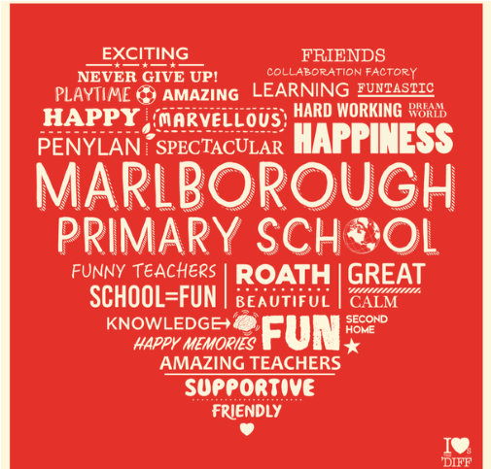
Please follow us for all the latest news!
@mps_pta
@Marlborough PTA E: marlboroughprimaryc@gmail.com

