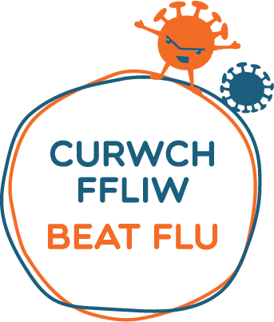

September 2020

Dear parent or guardian,
Help keep your child well this winter – make sure they have their flu vaccine
The school nursing immunisation team will visit school to offer a nasal spray flu vaccine to all the children on
05/10/2020.

All children of primary-school age are eligible and should have an Influenza (flu) vaccination every year.
If you have already completed a consent form this will be available at the session. Please request a form from the school if you have mislaid your child’s consent form. We will not be able to immunise your child unless the consent is available. Please return the consent form as soon as possible whether positive or negative.
The immunisation team have completed a detailed risk assessment and will follow the current guidance around social distancing and the use of personal protective equipment (PPE).

Thank you

