How to make meal bookings

- Go to www.parentpay.com and log in

- Select the child to make bookings for

- Select Bookings > Make or view bookings
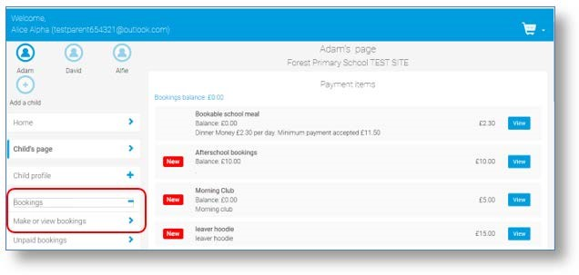
- Select the time of day that you wish to make a booking for

- Select the week to view

- Select Make or view bookings
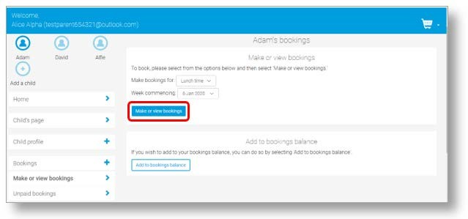
- You will then be presented with a booking screen.
- Menu selections: Book a meal by selecting from the menu choices shown
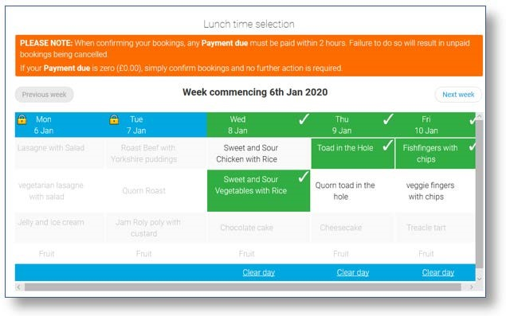
- Make the required bookings

- A summary will be displayed at the bottom of the page with any previous unpaid bookings shown in red
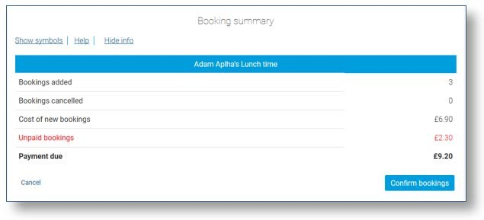
WARNING: Any bookings must be confirmed and (if required) paid for within 2 hours of selecting them. Failure to do so will result in the bookings being automatically cancelled.

- Review the booking summary, and select Confirm booking.

- Any credit in your Parent Account will be used to pay for the meals. Any remaining cost can be paid by Bank Transfer (if enabled), Visa Checkout or Other payment method
